Class 1 Handout

Setting up the Environment
To start working with C++, we are going to install an IDE. An IDE is “Integrated Development Environment”; It includes the text editor, the compiler that turns the C++ code to binary, and tools for debugging and more.

In the class, I will be using Code::Blocks, which is available for Windows, Linux, and OSX.
You can also use Microsoft Visual C++ Express 2010 if you would like; it is somewhat more polished and has better autocompletion, but choosing one over the other isn't really going to make-or-break your experience with C++ this early in.
Both of these are *free*!

Code::Blocks
http://www.codeblocks.org/

Microsoft Visual C++ Express
http://www.microsoft.com/visualstudio/eng/downloads#d-2010-express

If you're running a Linux operating system, you may also need to install G++. If you're running Debian, Ubuntu, or Linux Mint, you can do this through Synaptic.

Testing out the IDE with a first program

New Project
Let's write a quick program to make sure the IDE is working properly.
Open Code::Blocks, go to File > New > Project... Select Empty Project.
In the setup dialog box, enter a Project Title, and choose a directory to store the project in.
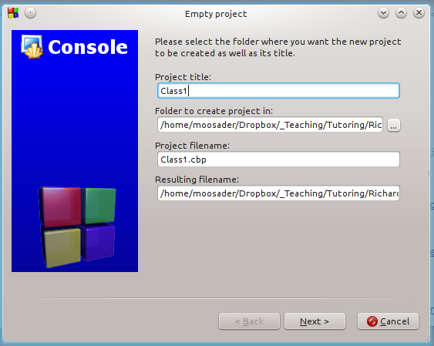

Hit Next, then Finish.

Creating main
We will now have an empty project. To write any code, we need to create a new Source file.
Go to File > New > Empty File (or CTLR+SHIFT+END). Name the file whatever you would like, and end it with “.cpp”. Make sure to add it to the active project.

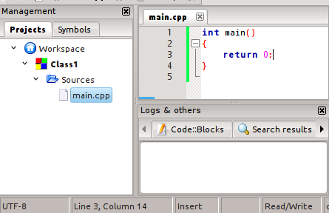

In C++, whenever you run a program, it will always look for main. This is the starting point, and if you're missing main, it will complain, saying “Undefined reference to main”.
We are returning a value of zero inside of our main block, and this just signifies that the program ended fine. We can use different numbers as error codes, so if something fails to load, we could return 2, 10, 50, or any arbitrary number. That way, if the program crashes and we get an error code, it helps us figure out where the program crashed.
On the same line as main, we have int. This means integer, and it means that main must return an integer. That's what our error-code is.

If we build the program, we should have no problems.
You can use the toolbar icons, go to the Build menu, or use F9 to Build & Run.
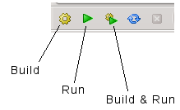

The program won't do anything yet, but the build output should show:
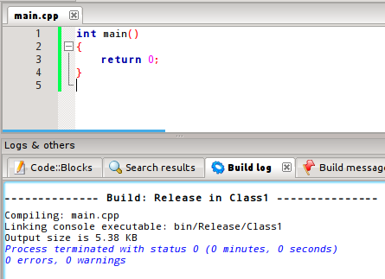

Zero errors, Zero warnings.
Let's add some input, output, and math before we move on to concepts.

In C++, we use “cout” (console out) to output text to the screen, and “cin” (console in) to input text from the user's keyboard. However, this won't work right off the bat!
C++ has a standard library with a lot of prewritten functionality, but you have to include parts of it at a time (otherwise, your .exe files would end up really big!)
We will use an #include statement to add these additional libraries. A library is essentially pre-written code, either by you, something from the standard library, or from another third-party.

#include <iostream>

int main()
{
std::cout << "Hello!" << std::endl;
std::cout << "How are you?" << std::endl;

return 0;
}

1. On the top line, we are including the standard library for input/output, “IO Stream”.
Streaming here is similar to how you would stream music or stream video online. Except in this context, it's streaming information between the keyboard and the program (input), and the program and the monitor (output). IO stands for Input/Output.

2. Then, inside main, we've added a line to output the text, “Hello!”
Because output is part of C++'s standard library, cout needs to be prefixed with std::.
At the end of the line, we have std::endl, which will create a new line. If the endl weren't there, the next line of text (“How are you?”) would show up on the same line as “Hello”.

3. When you run the program, you should see something like:
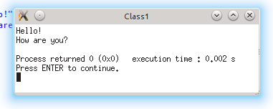

We can shorten our program a bit by telling it that we're going to use the std (standard) library.
using namespace std;

This will go after any #include lines. Now, our program is a little simpler:
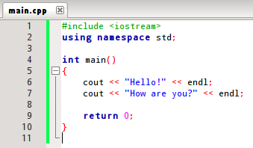

Now we can add some input to make things more interesting.
Similar to cout for console-output, we use cin for console-input. But, to get information from the user, we also need to set up variables to store information the program is given.
Variable Declaration looks like:
Datatype Variablename;
A Data Type is what a program uses to figure out what kind of data it holds. Some common types are:
- int – Integers. Whole numbers, positive, negative, and 0.
- float – Floats. 0, Positive & Negative numbers with decimal points.
- char – A single character; it could be any symbol such as numbers, letters, !@#$%, etc.
- string – A string of characters. If you were storing names, it would be in a string.
Let's make the program ask the user for two numbers, and then output the result when added together.
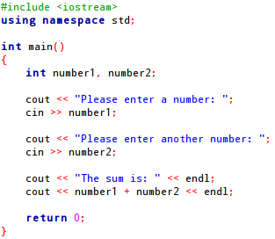

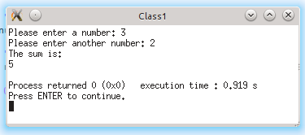

Syntax Notes!
We will get more in-depth into writing code a bit later, but for now I would like review some things with our program:
- In C++, commands end with a semi-colon. If you didn't have the semi-colon terminator, it would look at the next line to get additional instructions.
  - If Statements and While Loops contain commands, so these do not end with semi-colons.
- Statements that contain additional instructions (including main), will have curly-braces to signify the beginning and ending of its contents. It is important to keep the curly-braces straight. It is also standard to indent commands within curly-braces for readability.
- The cout and cin commands are followed by << and >>, respectively. These indicate that we're working with streams, but it is not important to fully grasp this yet.
- Don't forget to return 0; at the end of the program!

Object Oriented Programming
C++, as well as Java, C#, and some other languages, are Object Oriented languages. To solve every-day problems with computers, these languages model real-world Objects and Functionality in code.
This is called abstraction.
For example, we might want to write a program to keep track of or model the following:

Student and Class database for a college
For a school, we might want to keep track of Classes offered. Classes would have a title, short description, list of prerequisites, an assigned teacher, and a list of students registered for the class.
Students would have information like their first and last name, student ID number, address, GPA, a list of completed classes and grades, etc. etc.
We would be able to use functionality like “Add student to class x”, “Drop student from class x”, “Update GPA”, “Add completed class”.

An E-book
If we were abstracting a book into an e-book, the book would have data like a title, author, price, and a list of pages. Each page would have data like the actual text on the page.
The E-Book would have functionality like “Turn page forward”, “Turn page backward”, “Go to page x”, “Save page user is currently on”.

Think of abstraction in terms of Object, Functionality, and Attributes.
Car Object, Drive forward Functionality, Red color Attribute.
Oven Object, Set temperature to x Functionality, Current temperature Attribute.
Cat Object, Sleep Functionality, Breed Attribute.

